1. In this lecture, we will look at 3 concepts that each tie together to provide numerous advantages to use CLOUD COMPUTING
   1. High Availability
   2. Fault Tolerance
   3. Disaster Recovery
2. HIGH AVAILABILITY
   1. DEFINITION



* 1. Its based-on REDUNDANCIES at every level

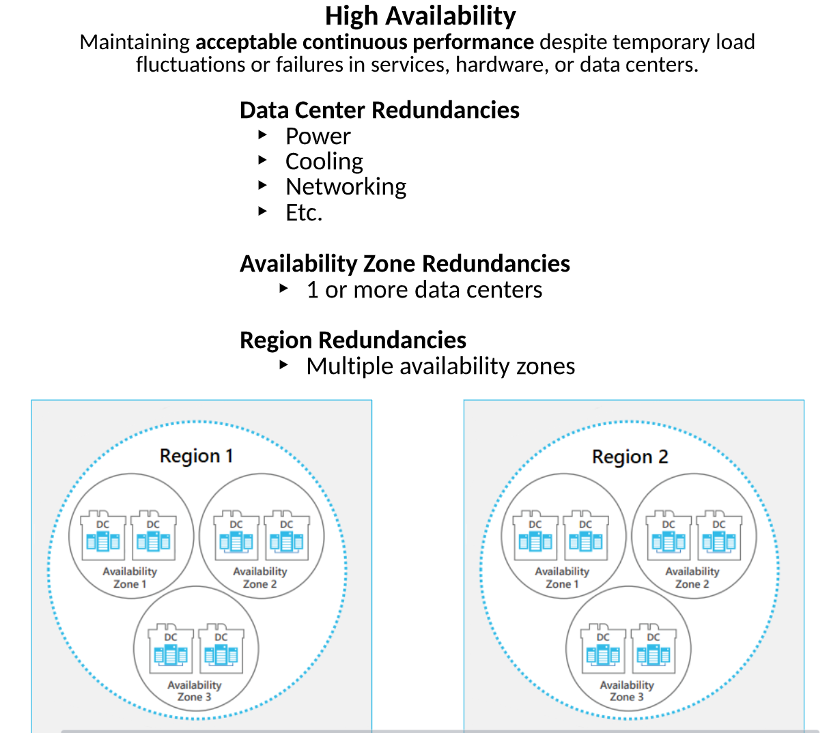

* + 1. DATA CENTER - Finest level – single individual data centre within AZURE. We will look up redundancies employed in DATA CENTER to make sure that everything stays UP as much as possible.
       1. POWER REDUNDANCY – The power systems in these data centers are fully redundant.
          1. Different providers power coming into the data center, if one has an interruption and the other stays up there is also battery backups etc.
       2. COLLING REDUNDANCY - They use different combination of cooling systems like WATER COOLING, AIR COOLING. Etc.
       3. NETWORKING – multiple internet providers coming in etc…
    2. AVAILABILITY ZONE – With in the DATA CENTER there is redundancy at every level but in case if something happens to entire DATA CENTER then we can step up level to AVAILABILITY ZONES where we see even more REDUNDANCY their.
       1. These are grouping of 1 or more DATA CENTERS put together
       2. We can deploy our APPs and our SYSTEMS to multiple AVAILABILITY ZONES for example, let says that we deployed 2 AVAILABLILITY ZONES, if DATA CENTER in 1 AVAILABLILITY ZONE goes down then still our applications and systems stay up.
    3. REGION REDUNDANCY – Moving higher level, consider if entire AVAILABLILITY ZONE goes down through NATURAL DISASTER etc. Well we have REGION REDUNDANCY.
       1. Region groups multiple AVAILABLILITY ZONES put together.
    4. We can deploy into multiple REGIONS to avoid more AVAILABILITY.

1. FAULT TOLERANCE
   1. Definition



* 1. There are 2 ways to look at becoming FAULT TOLERANT
     1. PROACTIVE options
     2. REACTIVE options

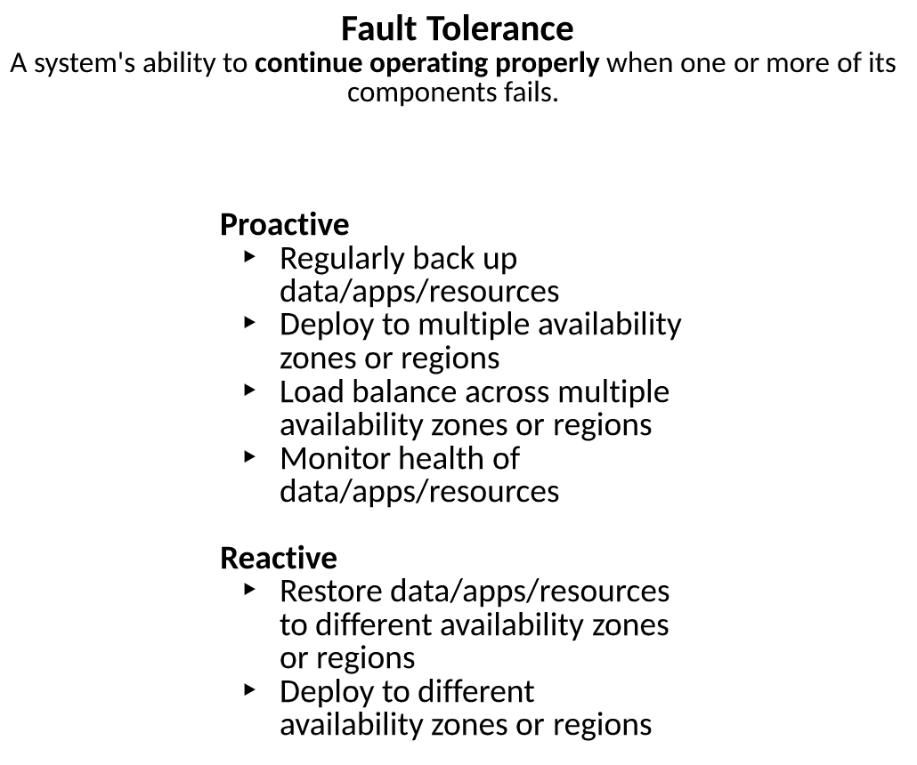

1. DISASTER RECOVERY
   1. Definition

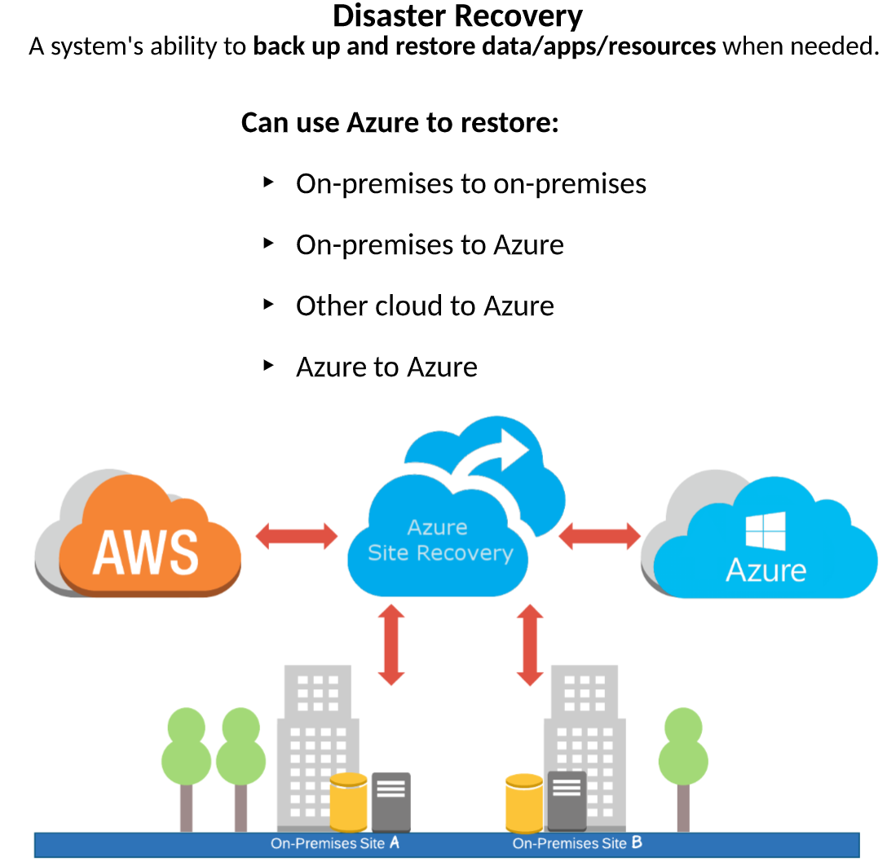

* 1. When a disaster does strike, we have the available options we need in order to restore our services and get them back up and running